Minimum IT System Requirements and Recommendations for eQSuite™

Internet Connection
As a Web-based application, eQSuite™ relies on a reliable high-speed internet connection such as business internet cable, business DSL or other reliable network connection.
Access to eQSuite™
Authorized users with a user name and password will access eQSuite:
- Through our website homepage: http://il.eqhs.org, by clicking eQSuite button located on the right side under eQHealth Web Systems.
- By creating a short cut on your desktop or saving link below as favorite Web site:
https://ilwebapps.eqhs.org/webportal/Login.aspx
Updated Web/Internet Browser
» To access eQSuite ™, the following hardware and software requirements must be met:
- Computer with Intel Pentium 4 or higher CPU and monitor
- Windows XP SP2 or higher
- 1 GB free hard drive space, 512 MB memory, Broadband Internet connection
» eQSuite™ requires internet browsers that support HTML5 as well as the latest W3C standards.
» eQHealth supports the current version and two prior major releases of any of the following: Chrome Firefox Internet Explorer Safari
» The following browsers and their predecessors are no longer supported: Firefox 3.5, Internet Explorer 7, and Safari 3
To check the Internet Browser you have on your computer, first connect to the Internet and then click on “Help” from the menu bar:
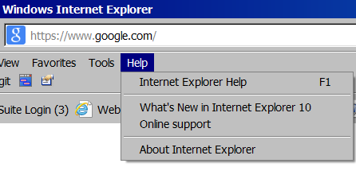
CONTACT YOUR HOSPITAL IT CONTACT OR HELPDESK FOR ASSISTANCE
Minimum IT System Requirements and Recommendations for eQSuite™
Adobe Reader
eQSuite™ displays portable document files (PDF) using Adobe Reader. These files “pop-up” and show as non-editable documents that can be viewed or printed easily from your computer.
REMINDER: Turn OFF your pop-up blocker to allow for reports or letters to be viewed online. To turn off pop-up blocker, connect to the Internet and click on “Tools” from your menu bar, or ask your IT representative to adjust your Pop-up blocker settings when you’re on eQSuite™:
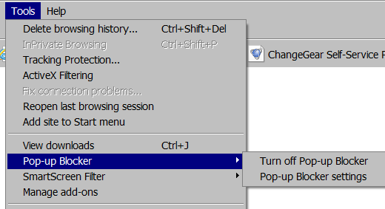
Computer Screen Recommendations
Any computer screen will work, but eQSuite™ works best with a screen resolution of 1024 x 768 pixels – you’ll be able to see and work on more information on the screen without scrolling.
You can also use F11 on your keyboard to see your full screen when working with eQSuite™.
Compatibility View
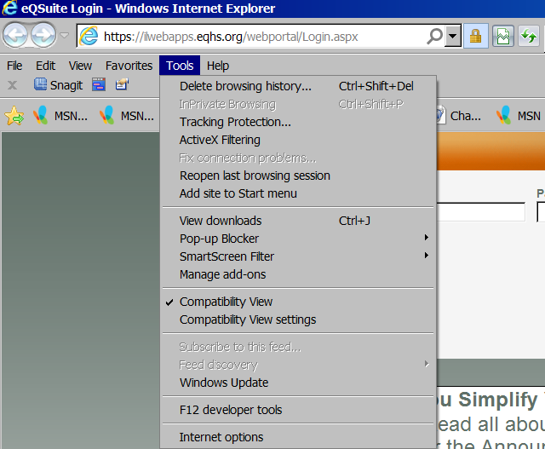
CONTACT YOUR HOSPITAL IT CONTACT OR HELPDESK FOR ASSISTANCE

